**Project Title:** Formatting Linux and Installing Windows Operating System

**Objectives:**

* This project is to understand how to create a bootable media for windows installation
* This project is to learn the process of installing windows on a computer
* This project is to understand basic installation set up and configuration

**Methodology:**

Step 1: First I am downloading Windows 10 ISO file from web browser. Windows have many versions like Windows 7, Windows 8, Windows 10, Windows 11 but I am choosing Windows 10 here.

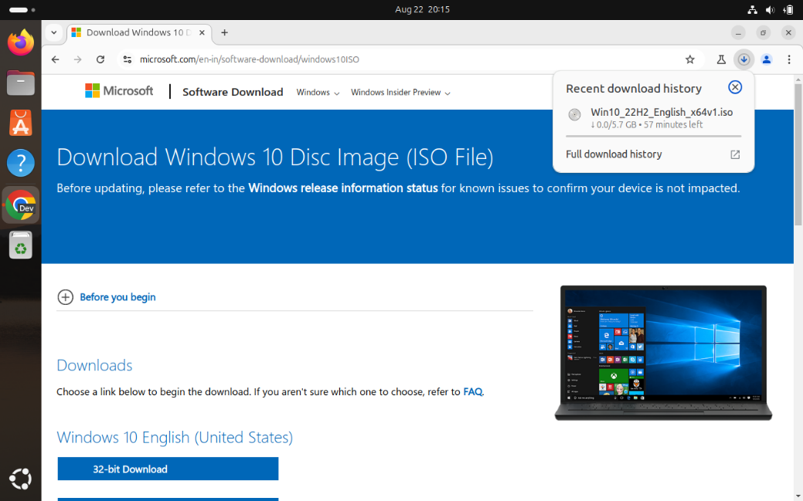

Step 2: Next I have to install WoeUSB. WoeUSB is a tool that help us to create bootable Windows USB drive from ISO files. To install WoeUSB, first I am adding the WoeUSB PPA (Personal Package Archive) using command **sudo add-apt-repository ppa:tomtomtom/woeusb**

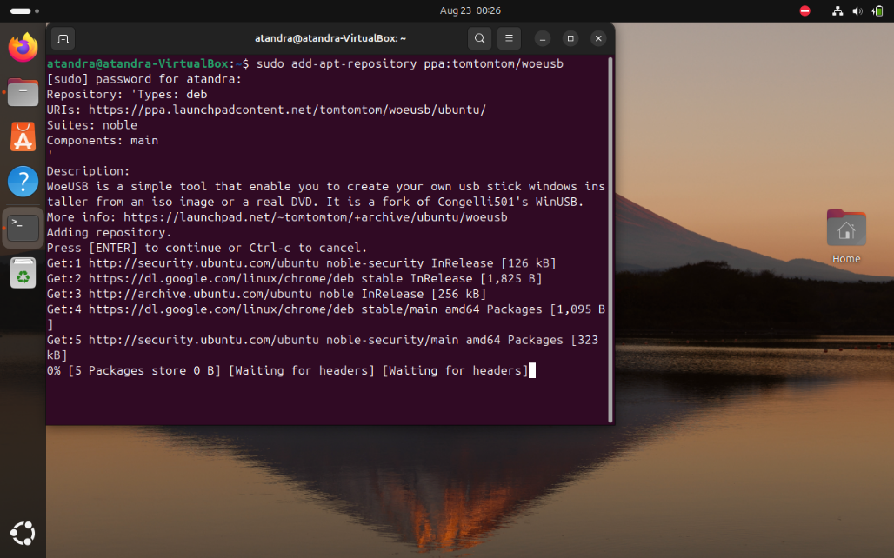

Step 3: Next I am updating packages list using command **sudo apt update .**

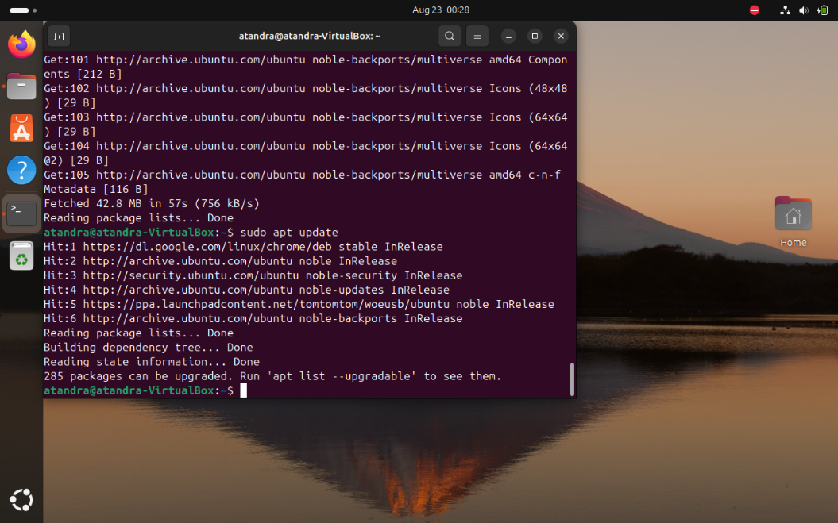

Step 4: Now I am installing WoeUSB using command **sudo apt install woeusb-frontend-wxgtk**

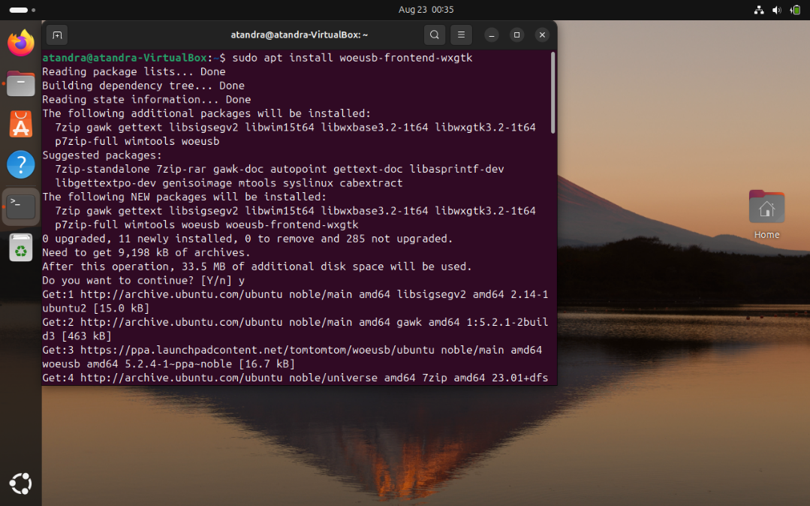

Step 5: Next I have inserted my USB Drive in my computer system, and now I am checking if my USB Drive is mounted or not using command **df -h** . Here /dev/sdb1 is appearing in the list that means my USB Drive is mounted.

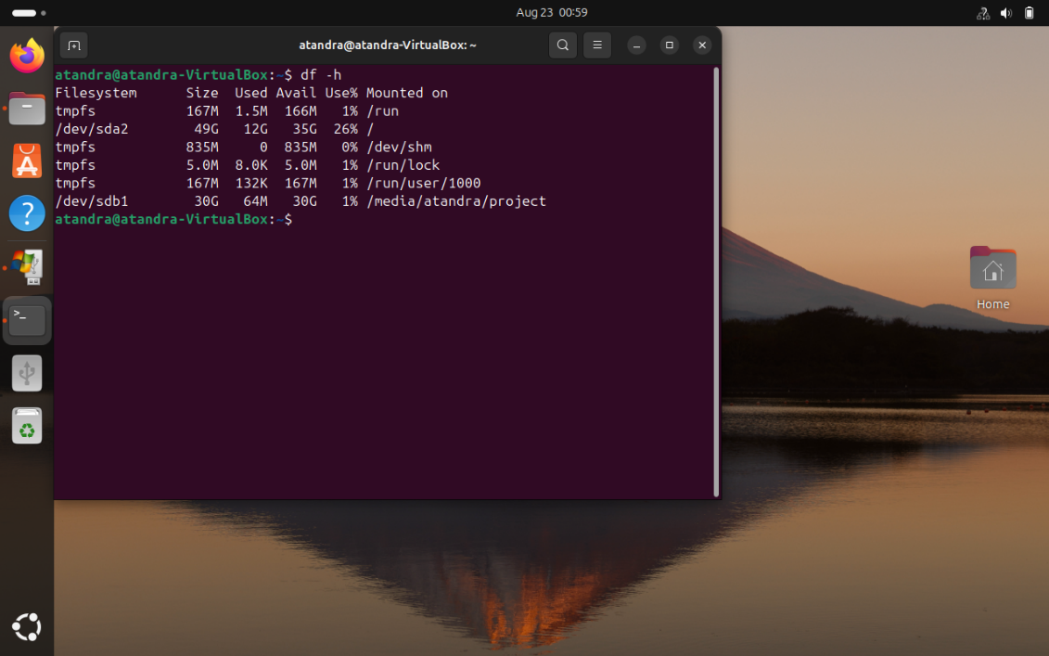

Step 6: Now first I am unmounting my USB Drive using command **sudo umount /dev/sdb1** , before make my USB Drive bootable to avoid such issues like Data corruption, File system conflicts.

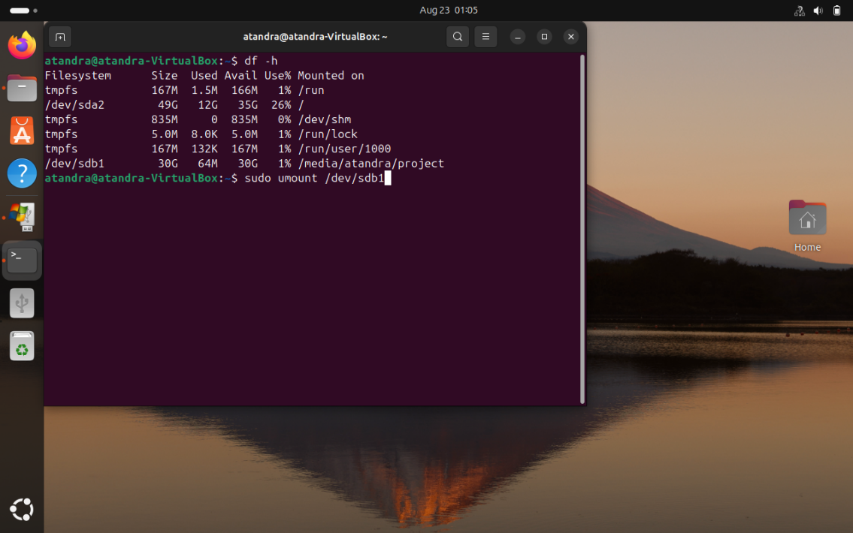

Step 7: Again, I am using **df -h** command to check if my USB Drive is unmounted or not. Here /dev/sdb1 is not showing in the list that mean my USB Drive is unmounted.

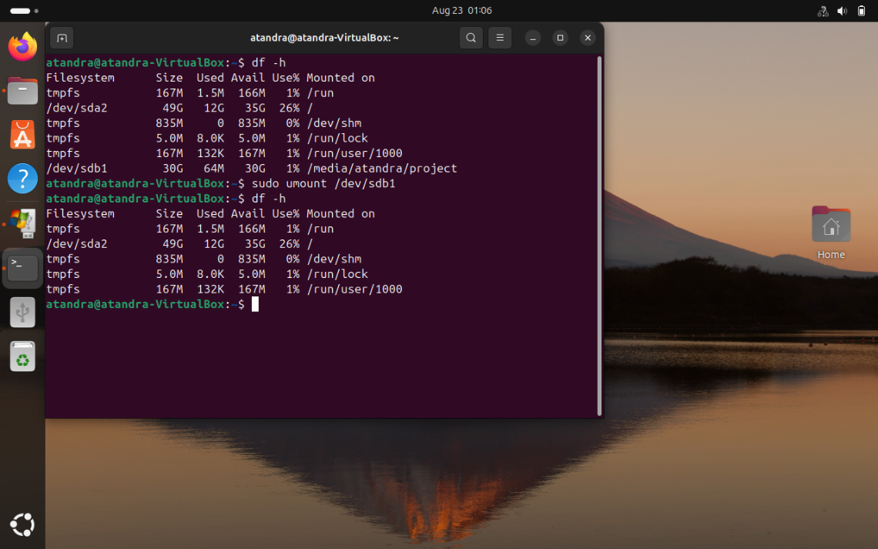

Step 8: Now I have opened WoeUSB and selected the Windows 10 ISO file in Disk image section. Selected my USB Drive in Target device section. Next, I have chosen NTFS as filesystem because NTFS include many features like encryption, faster access speed, security. Now everything is set and I have to click on Install option.

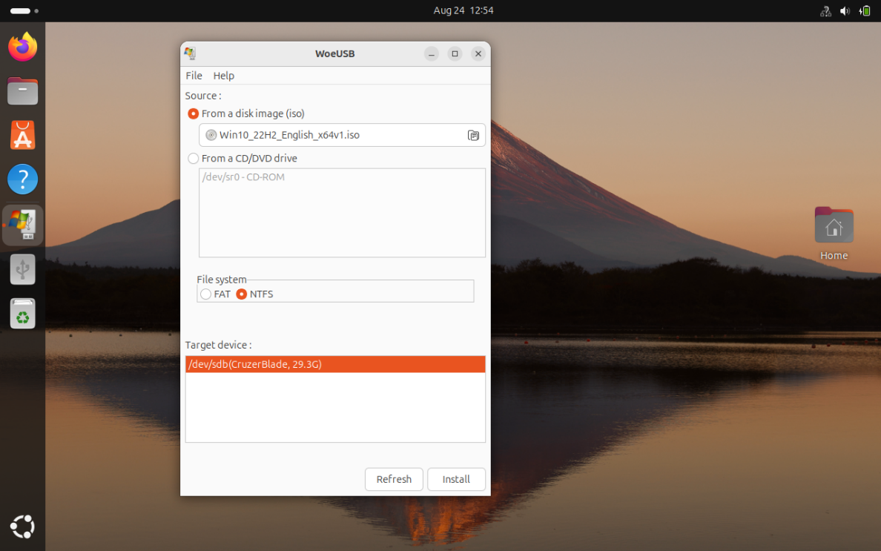

Step 9: Now it is asking for Authentication, so here I have to put the password of my computer system and click on Authenticate option.

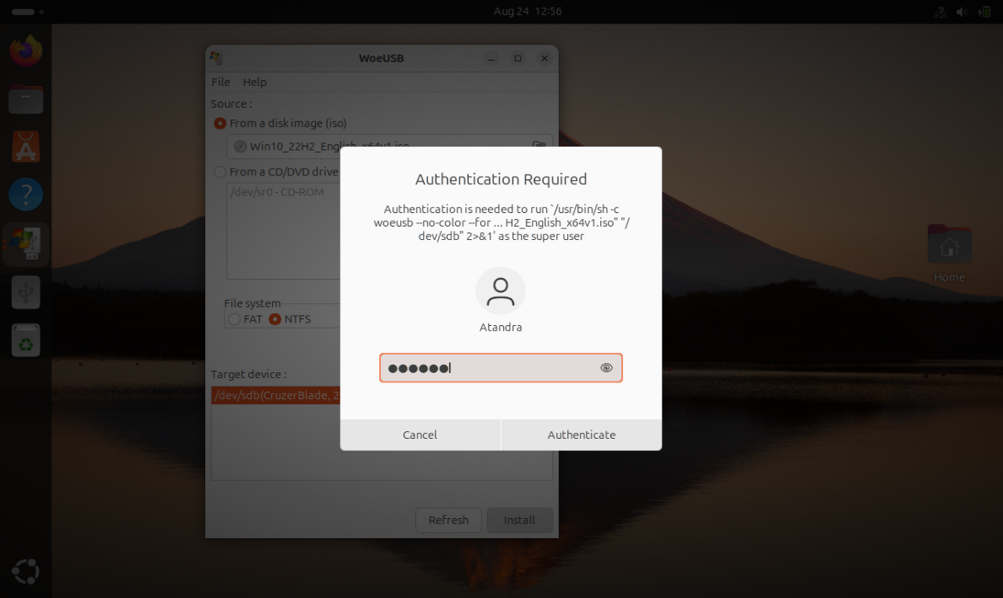

After Authentication, Installation process has been started.

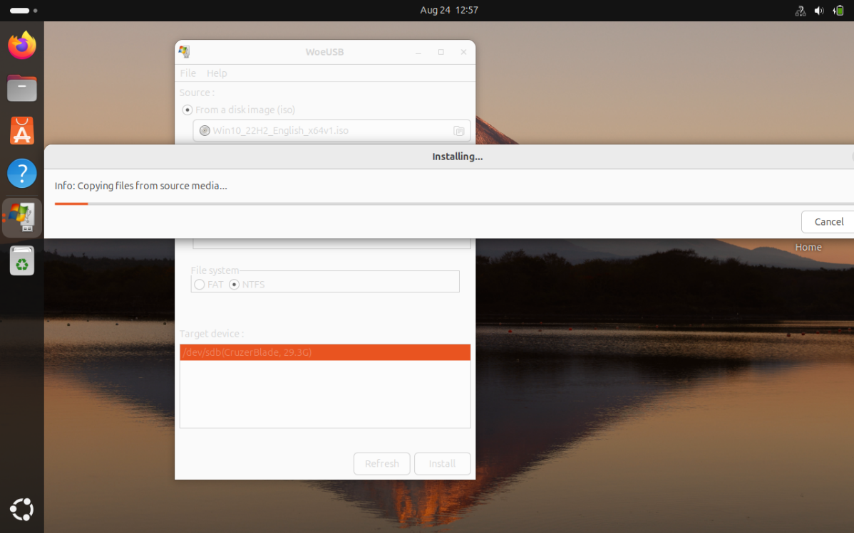

And finally, my USB Drive become Bootable Windows Drive.

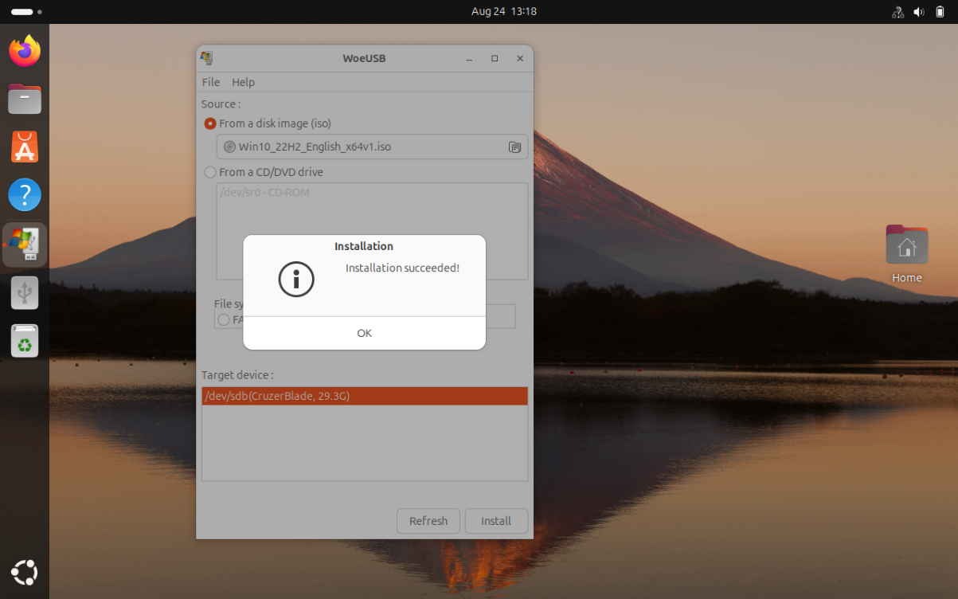

Step 10: Now I have to change the Boot order in BIOS. So, for that I have entered into BIOS by pressing F2 or F12 or Del key after restarting my computer before log in screen loads. Now I am selecting USB Storage Device in Boot order and have to press Enter.

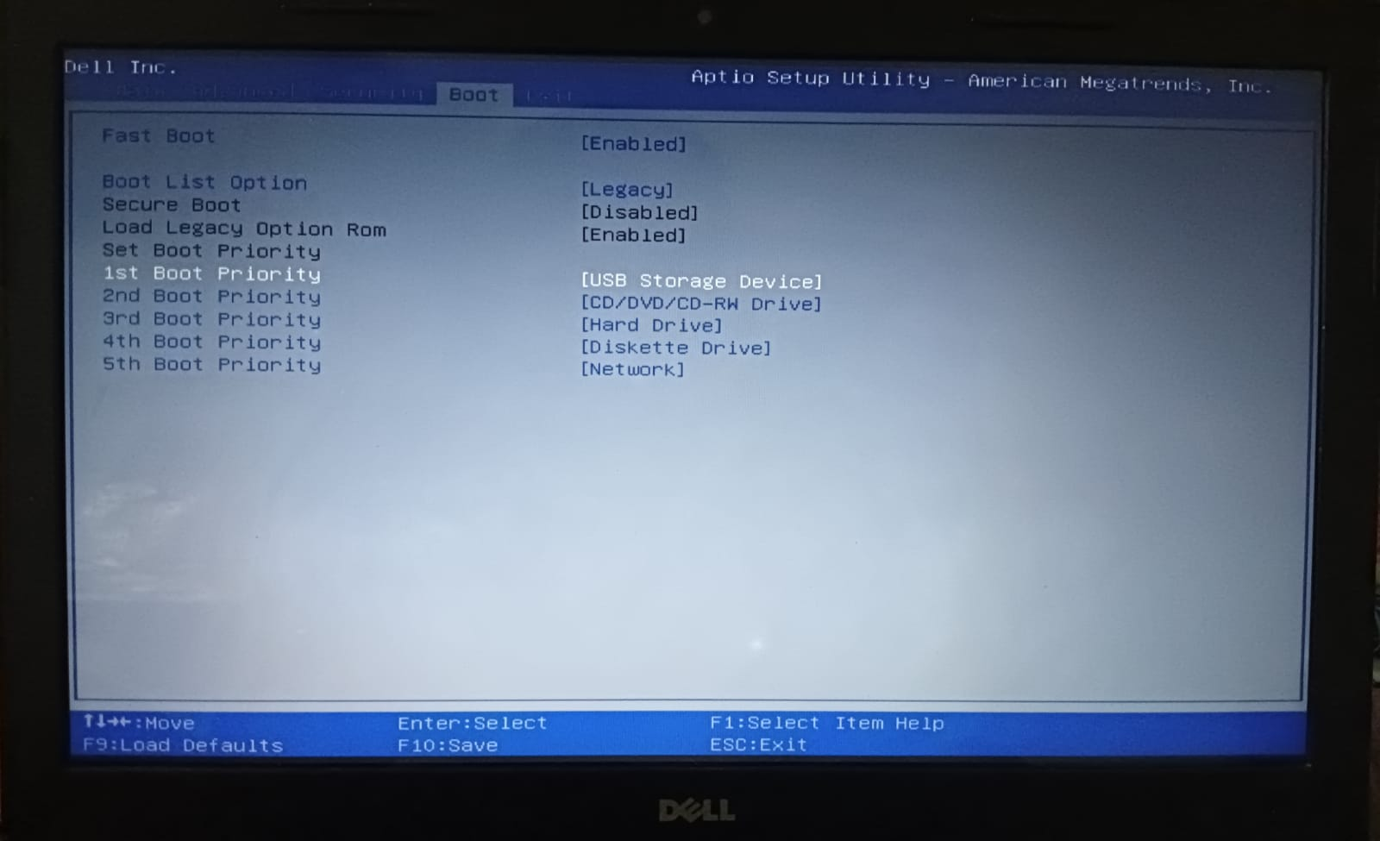

Step 11: Now an interface is appearing for installing Windows 10. Here I will select my suitable options in the field and click on Next.

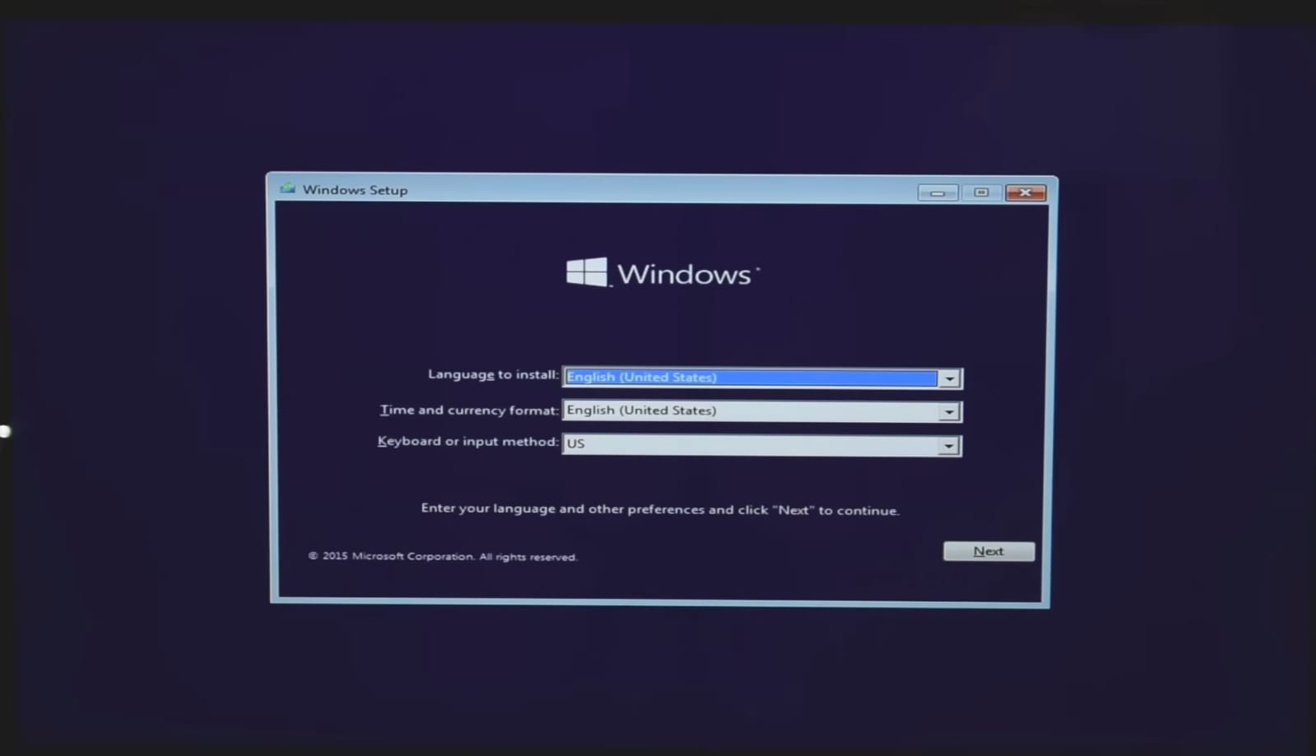

Step 12: Here I can put the product key of my Windows 10 for activation or I can do it later.

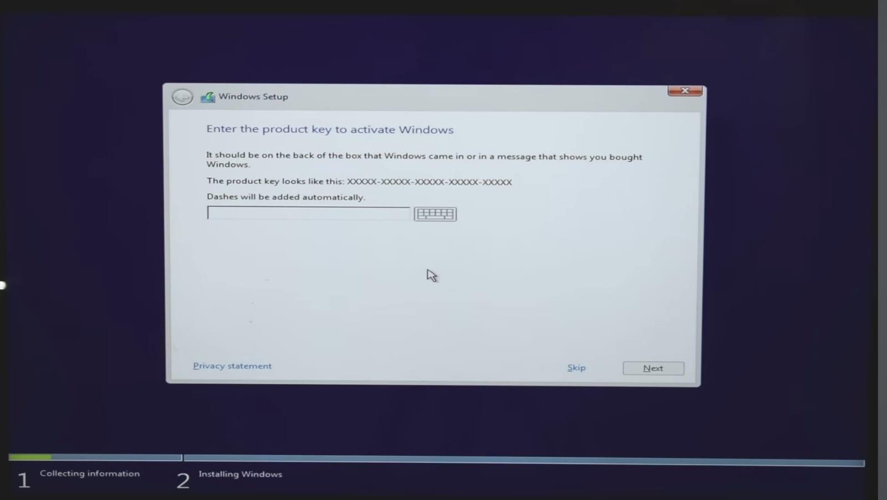

Step 13: Next I am choosing Custom Install option to perform a clean & fresh install of Windows 10.

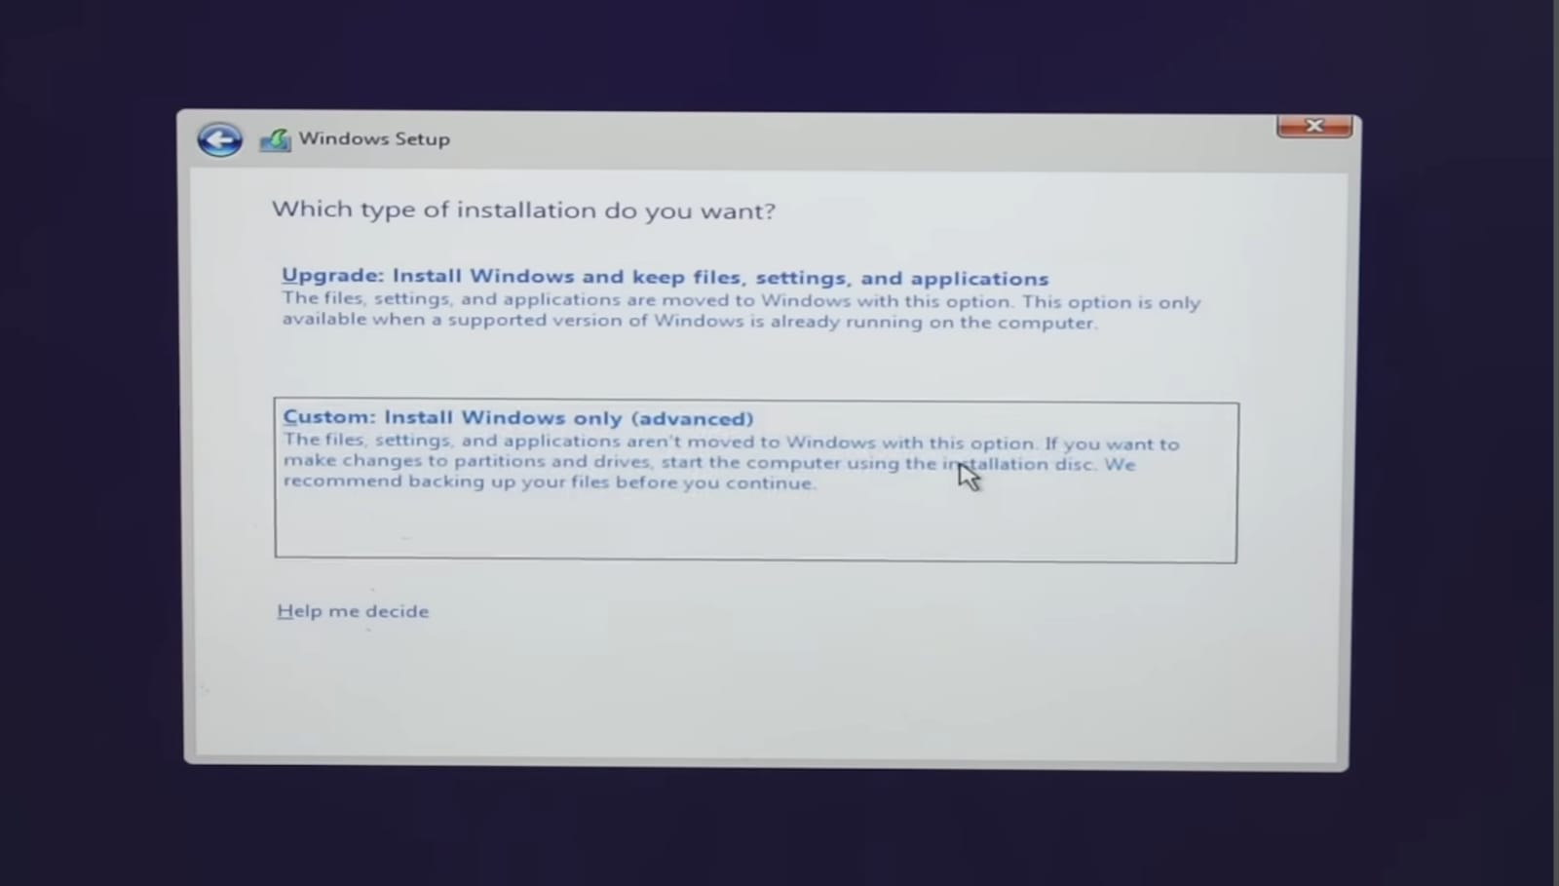

Step 14: Next Disk Partitioning interface is appearing. Here I can delete any partition and create any new partition.

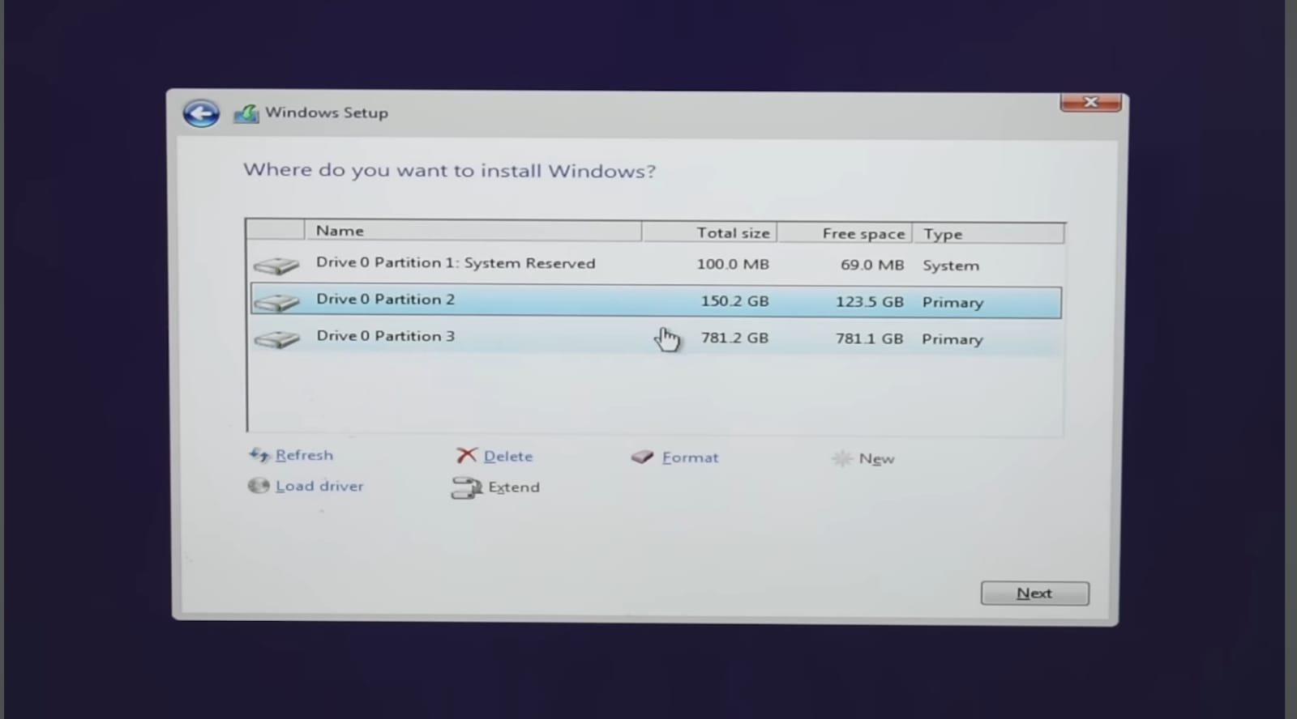

Step 15: It is mandatory to delete System Reserve space and the partition where my old operating system was installed and to create a new partition from the unallocated space. Here, I am deleting **Disk 0 Partition 1** because my old operating system was installed in this particular partition. After completing partition process, I have to select the particular partition where I will Install my new operating system Windows 10 and click on Next.

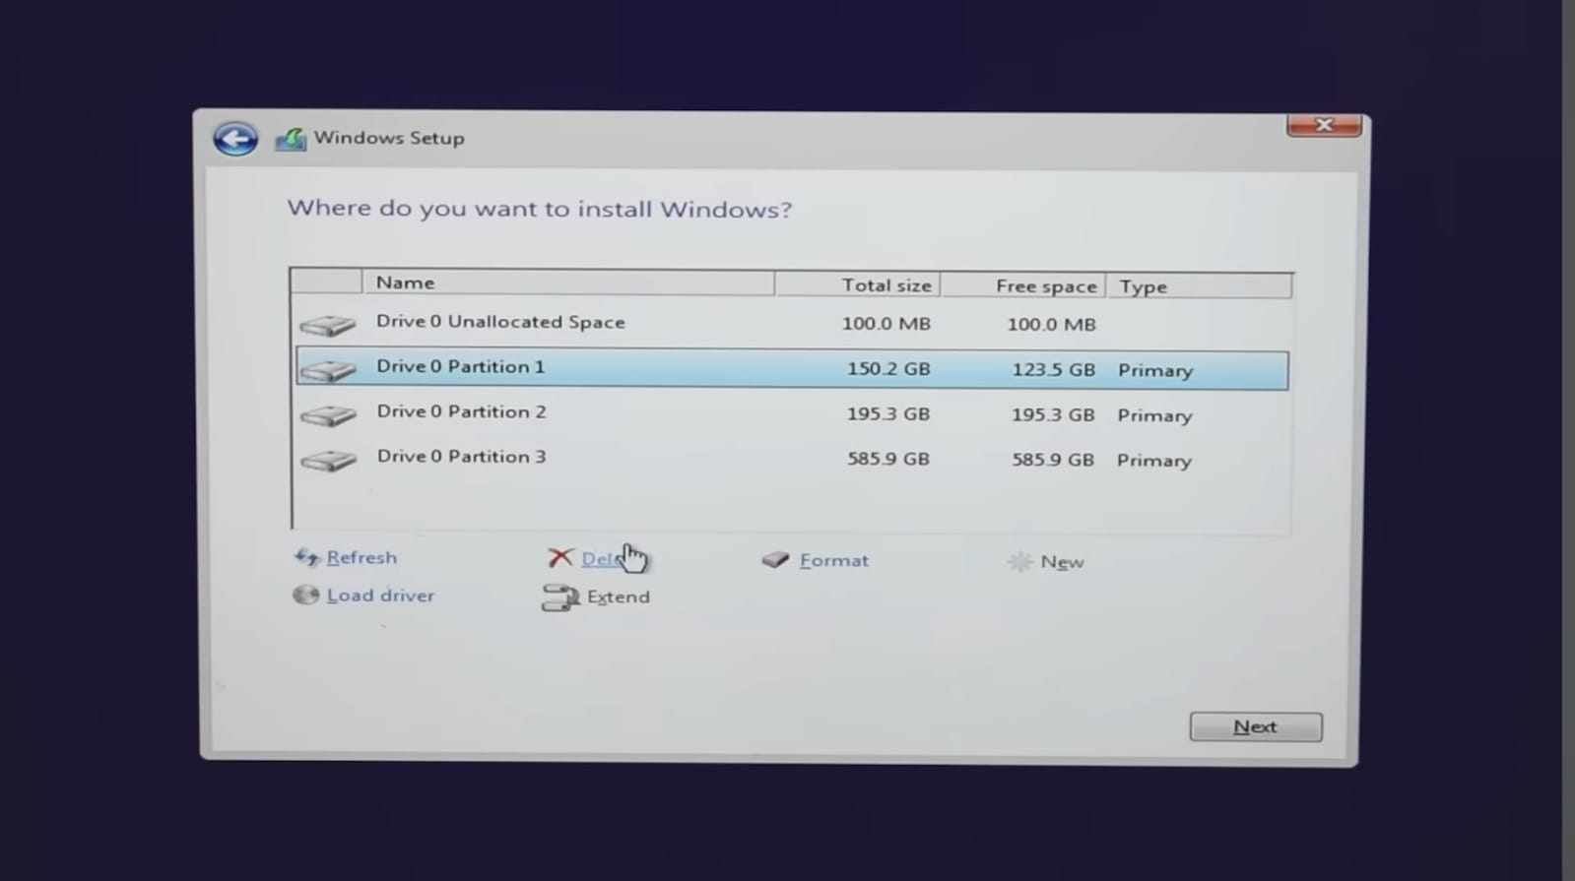

Step 16: Finally, installation of Windows has been started.

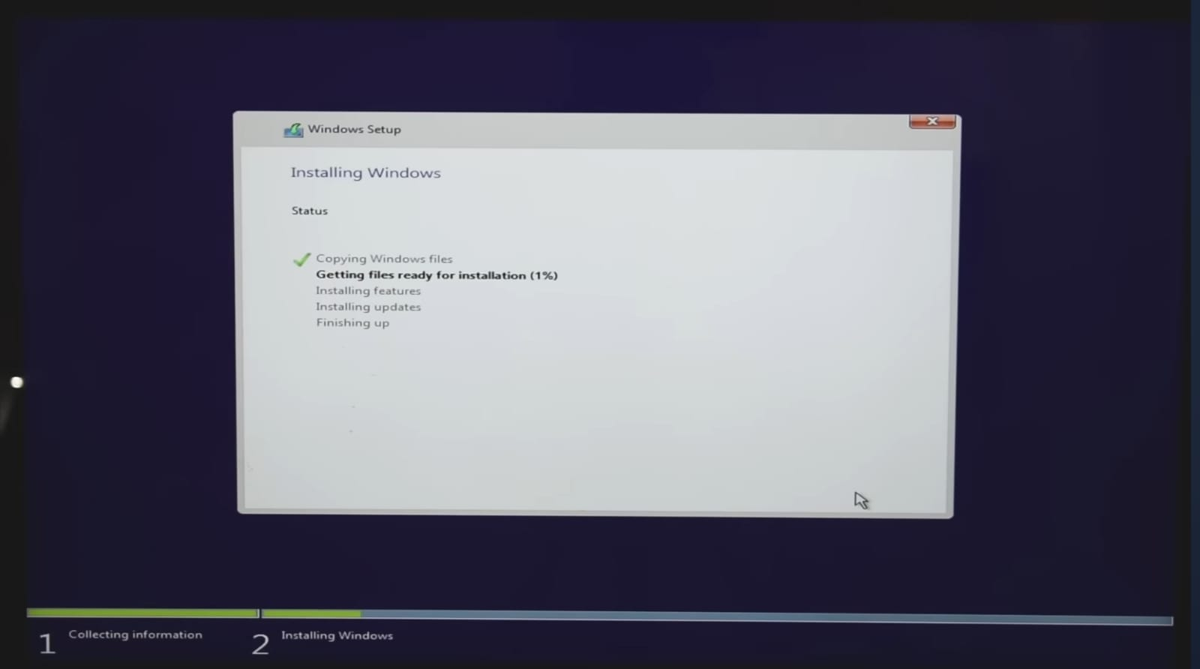

Step 17: Now I have to choose Username & Password for my Windows 10 operating system.

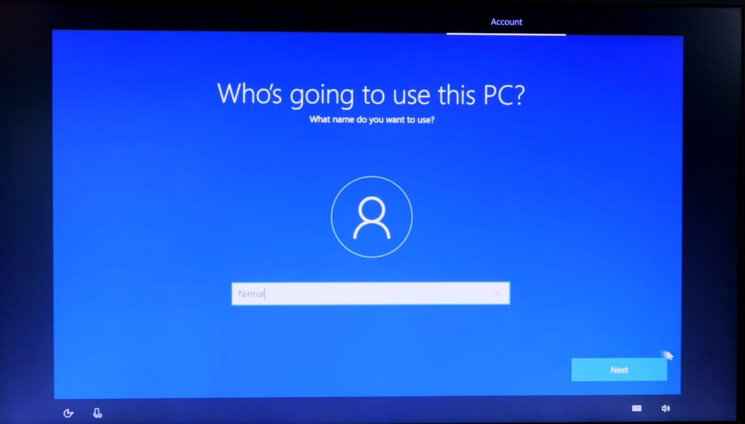

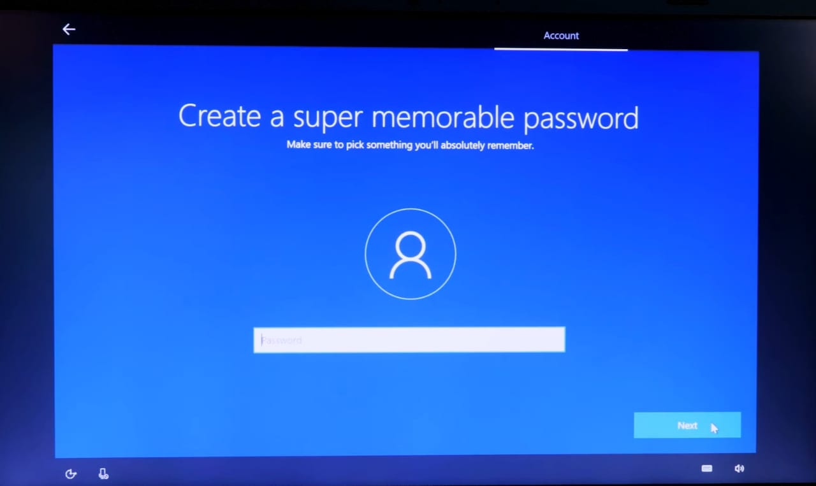

Step 18: Finally, I have logged into my system.

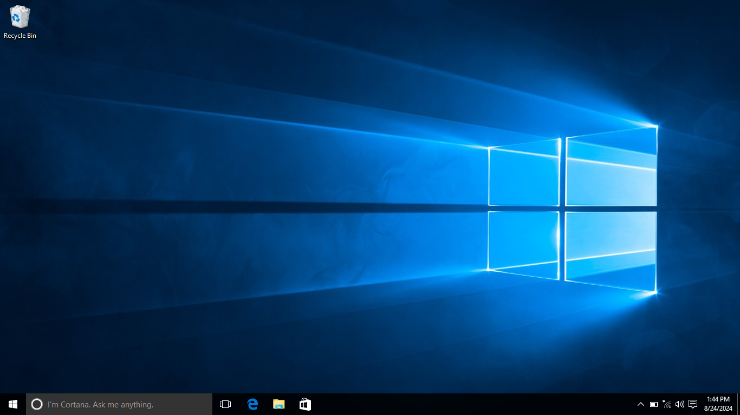

**Conclusion:**

This project has provided a comprehensive guide to installing windows operating system on a computer. By following this steps user can confidently install the windows operating system, and optimize their system for performance.

This knowledge is essential for IT professionals to manage their own computer systems.